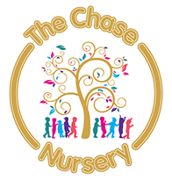

Price list from April 2025
Kirby Clacton and Holland Park
Age | Hourly cost
0-2 years | £8.14
2-3 years | £7.92
3-4 years | £7.59

Holland
Age | Hourly cost
0-2 years | £9.35
2-3 years | £7.92
3-4 years | £7.59

Snack fee for all settings is 50p per ½ a day session, £1 for a full day session.

